Contents
1 Cloud Network - Threat Analysis 2
1.1 Introduction 2
1.1.1 Types of Cloud Networks and VPCs 2
1.1.2 Key elements related to Cloud Network Security 3
1.1.3 Security Considerations in typical Cloud Networks 4
1.1.3.1 The Design consideration, Vulnerabilities, threats etc 4
1.1.3.2 Analysing threats in a multilayer Single cloud Network 6
2 Cloud Network Architecture Review 8
2.1 Architecture Overview & Topology 8
2.2 High-Level Network Diagram: 8
2.3 Security Boundaries: Cloud-Native DMZ Analysis 10
2.4 Traffic Flow & Egress Analysis 10
2.4.1 NAT Gateway Implementation 11
2.4.2 Security Controls and Risk Mitigation 11
3 Vulnerability Identification Report 12
4 Best Practice Comparison 12
5 Threat Scenario Analysis 12
5.1 Security Considerations of concerned Network Architecture 12
5.1.1 Security threats 13
5.1.2 Criticality and Cost Optimization 16
5.1.3 Security threats arising from delivery models 17
5.1.4 Real Life examples of Security incidences for a Single VPC. 19
6 Improvement Suggestions 20
7 Executive Summary 20
8 Reference list 20

Cloud Network - Threat Analysis

Introduction
Cloud network architecture represents a fundamental shift from traditional on-premises infrastructure, introducing new paradigms in security, scalability, and operational efficiency. This section examines the architectural foundations of cloud-native networking, comparing modern Virtual Private Cloud (VPC) implementations with traditional perimeter-based approaches. Through analysis of tier separation, traffic flow patterns, and security controls, we establish the framework for understanding contemporary cloud network security.
The primary difference between cloud networks and traditional networks lies in how the infrastructure is how they are created/configured, managed, scaled, and therefore secured.
Traditional or the older way of providing networking solution is by means of providing physical hardware (racks, cables, and manual configuration), while cloud networks are Software-Defined (SDN) Networks, replacing the hardware layer of the traditional set up into virtualized services.
Another concept within Cloud Network is of VPC- A VPC or Virtual Private Cloud is a private, isolated network environment created within a public cloud (like AWS, Azure, or Google Cloud). Think of it as a "private slice" of a shared public cloud infrastructure.
While the physical hardware of the Public Cloud provider is shared with other customers (multi-tenancy), the individual customer’s VPC is logically isolated using virtual network functions, ensuring your data and traffic remain private.
This set up therefore demands a different security perspective.
While the traditional networks rely on edge specific protection such as Firewalls, the Cloud network do compartmentalization- “Micro-segmentation” using concept called “Security Groups” that follow the resource rather than port.
Additionally, expansion of the traditional networks are tough- with physical arrangement is needed, while Cloud networks are quite scalable and elastic therefore easy but then the expansion needs to be considered with due considerations while expanding which may get overlooked.

Types of Cloud Networks and VPCs
Cloud networks are broadly categorized into Public, Private, Hybrid, and Multi Cloud models, while VPC (Virtual Private Cloud) networks are isolated virtual networks within cloud providers like AWS or Google Cloud, offering subnets, route tables, gateways, and security controls. Below are authoritative sources with direct links.

Types of Cloud Networks
Public Cloud – Services delivered over the internet by providers like AWS, Azure, or Google Cloud.
Private Cloud – Dedicated infrastructure for one organization, offering more control and security.
Hybrid Cloud – Combines public and private cloud resources for flexibility and scalability.
Multi Cloud – Uses multiple cloud providers simultaneously to avoid vendor lock in and improve resilience.

Types of VPCs
A Virtual Private Cloud (VPC) is a logically isolated virtual network within a cloud provider. Different VPC network types are defined by how subnets, gateways, and connectivity are configured:
Public Subnet – Directly connected to the internet via an Internet Gateway; used for load balancers, bastion hosts, NAT gateways.
Private Subnet – No direct internet access; resources here use private IPs and rely on NAT gateways for outbound traffic.
Hybrid Connectivity VPCs – Connect on premises networks to cloud VPCs via VPN tunnels or Direct Connect/Interconnect.
Shared VPCs (Google Cloud) – Multiple projects share a common VPC network for centralized management.

Key elements related to Cloud Network Security
Due to complete virtualization of the network there are some key areas of the VPCs need to be paid some special attention. Following are (some of) the key areas related to the security perspectives:

VPC Design
VPC Design is the process of architecting a logically isolated virtual network in the cloud. A well-designed VPC ensures scalability, security, and high availability.
It involves CIDR block planning, subnet segmentation (public/private), routing tables, gateways, and security controls.

Security Groups
These act as a virtual firewall for instances (e.g., EC2). They are stateful, meaning if an inbound request is allowed, the outbound response is automatically permitted. They control inbound and outbound traffic for EC2 instances or other resources.

Network ACLs
The Network Access Control Lists are stateless firewalls applied at the subnet level. They allow or deny traffic explicitly, requiring rules for both inbound and outbound flows.

Transit gateways
A network hub used to interconnect multiple VPCs and on-premises networks. It simplifies networking by acting as a central router, replacing complex "mesh" peering configuration (and enables hub-and-spoke architecture).

Security Considerations in typical Cloud Networks

The Design consideration, Vulnerabilities, threats etc.
The different kind Cloud Networks pose different needs from design point view, have different challenges in terms of vulnerabilities and threats. Designing a cloud network requires balancing control, cost, and scalability while addressing the unique security risks inherent in each deployment model.
- Public Cloud: Most exposed due to shared infrastructure; requires strong IAM and encryption.
- Private Cloud: Offers control but vulnerable to insider misuse; zero-trust and audits are critical.
- Hybrid Cloud: Complexity introduces risks; visibility and secure connectivity are priorities.
Multi-Cloud: Expands attack surface; unified governance and monitoring are essential.

Following is an overview of the typical design considerations, vulnerabilities threats in different kind of Cloud Networks.

Cloud Network Type | Design Considerations | Vulnerabilities | Threats
Public Cloud | Shared Responsibility/ Infrastructure – Multi tenant environment- Resource pooling;  Global availability Elasticity & Scalability;. | Misconfigured S3/storage buckets;  weak identities,  Insecure APIs;  data exposure,  Lack of visibility into provider infrastructure. | Account hijacking; DDoS attacks; Insider threats, Data breaches (for e.g. via credential theft);  API exploits. Compliance violations
Private Cloud | Dedicated Infrastructure;  High Control/ Customization; CAPEX heavy;  Data sovereignty. | Single point of failure; Outdated/Unpatched legacy hardware;  Weak Access control;  Outdated Patches;  Insider Misuse and Shadow IT within internal units. | Malicious insiders;  Unauthorized access;  Data leakage;  Compliance Gaps  Resource exhaustion; Ransomware moving laterally;  Physical site breaches.
Hybrid Cloud | Secure Interconnects (VPN/Direct Link); Integration of On premises and Public/private cloud;  Policy consistency; Cloud Bursting capabilities. | Inter-cloud data exposure; Inconsistent security policies;  Insecure VPN;  Visibility Gaps  Complex logging/audit trails across environments. | Lateral movement from on-prem to cloud;  Identity sync/federation exploits;  Token theft;  Data interception;  Misconfigured connections;  Third Party risks.
Multi-Cloud | Vendor lock-in avoidance- work load distrubution;  Interoperability; Diverse compliance management. | Fragmented visibility; Management complexity; Overlapping or conflicting security tools, Misconfiguration | Data sprawl; Compliance drift; Increased attack surface due to multiple cloud providers.

Analysing threats in a multilayer Single cloud Network
The network architecture type 3/multi-layer Single Cloud network, is perhaps with least security challenges as compared to complex, Hub and Spoke or Hybrid models.
And yet its threat scenario evaluation requires a structured approach that looks at each layer (Web/Public, Application/Private, Data/Restricted) and the interactions between them. The goal is to identify vulnerabilities, attack vectors, and mitigation strategies across tiers.
To analyse threat scenarios for a Multi-Tier Architecture within a single Virtual Private Cloud (VPC), one must look at how data flows between layers (Web, Application, and Database) and where the "trust boundaries" are.
The most effective methods to analyse these threats involve a combination of structural modelling and "outside-in" testing.

Following are some of the key methods which are typically used in analysing this kind of network.
- STRIDE Threat Modelling
Developed by Microsoft, STRIDE is the gold standard for breaking down what can go wrong in a segmented network.
- Spoofing: Can a compromised App server spoof the identity of an admin?
- Tampering: Can data be altered as it moves between tiers?
- Repudiation: Are logs sufficient to prove who accessed the Database?
- Information Disclosure: Is sensitive data unencrypted in the VPC?
- Denial of Service: Is there a bottleneck in the NAT Gateway?

- Attack Path Mapping (Lateral Movement Analysis)
In a single VPC, the biggest threat is Lateral Movement. If an attacker compromises a Public Subnet (Web Tier), you must analyze the path to the Private Subnet (DB Tier).
  - Security Group Analysis: Check for "Any/Any" rules that allow broad traffic between tiers.
  - Identity-Based Paths: Check if the IAM role attached to the Web server has permissions to read from the Database S3 buckets or RDS directly.

- Layered Threat Modelling
  - Break down the architecture into Web Tier, Application Tier, and Data Tier.
  - Identify threats specific to each:
  - Web Tier (Public Subnets) → DDoS, SQL injection, cross site scripting, exposed load balancers.
  - Application Tier (Private Subnets) → privilege escalation, insecure APIs, lateral movement.
  - Data Tier (Restricted Subnets) → unauthorized access, data exfiltration, replication misconfigurations.
- Traffic Flow & Segmentation Analysis
  - Map north south traffic (internet ↔ web tier) and east west traffic (between app and data tiers).
  - Ensure segmentation with security groups and NACLs to prevent lateral movement.
- Attack Surface Enumeration
  - Use CSPM (Cloud Security Posture Management) tools to scan for misconfigurations.
  - Check for:
  - Open ports in security groups.
  - Overly permissive IAM roles.
  - Unencrypted data in transit or at rest.
- Simulation & Penetration Testing
  - Conduct red team exercises simulating attacks:
  - Compromised web server → pivot to app tier.
  - Misconfigured NAT gateway → data exfiltration.
  - Use MITRE ATT&CK framework to model adversary techniques.
- Monitoring & Logging
  - Enable VPC Flow Logs to monitor traffic anomalies.
  - Integrate with SIEM tools for real time detection.
  - Apply CloudTrail for API activity tracking.
- Automated Configuration Auditing
Manual analysis is prone to error. Use tools to find "Misconfiguration Vulnerabilities" which account for the majority of cloud breaches.
- Tools: Use AWS Inspector, Azure Advisor, or Google Cloud Security Health Analytics.
- What to look for: Overly permissive Security Groups, unencrypted volumes, and publicly accessible snapshots.

Cloud Network Architecture Review

Architecture Overview & Topology
The proposed cloud network architecture implements a robust 3-Tier Virtual Private Cloud (VPC) design. This architecture prioritizes defense-in-depth security, strict separation of duties, and high availability by spanning resources across two Availability Zones.
The network topology is segmented into three distinct logical tiers, ensuring that traffic flows securely from the internet to the web layer, then to the application logic, and finally to the data store, with no direct access permitted between the internet and the data tier.

High-Level Network Diagram:
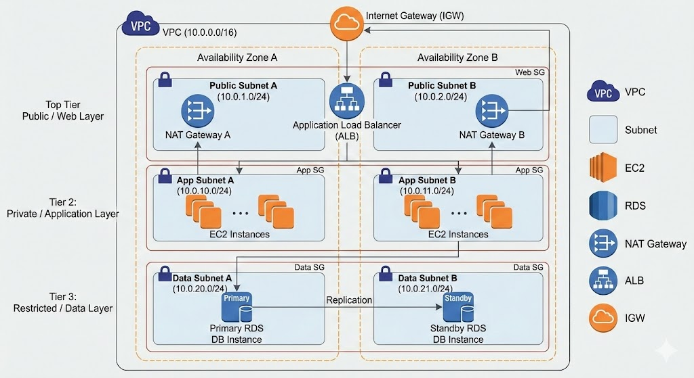

Data Flow Diagram:
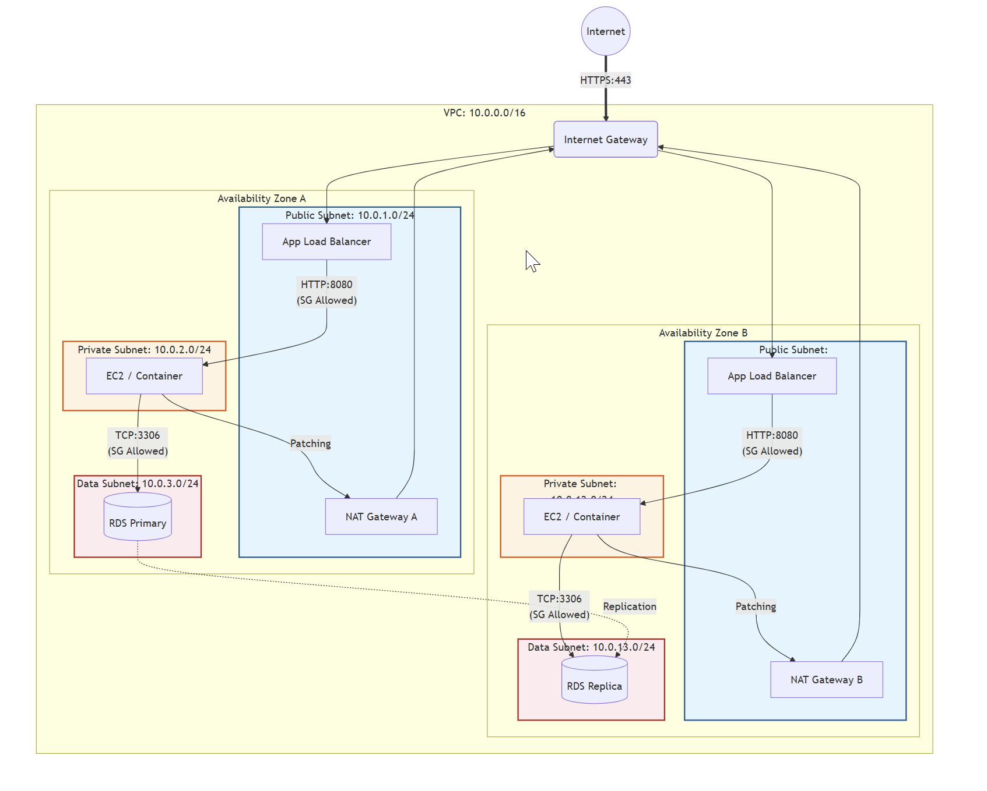Tier Definitions & Connectivity: The following table details the purpose and connectivity profile for each tier within the architecture:
Tier | Type | Purpose | Connectivity Profile
Web Tier | Public | Hosts Application Load Balancers (ALB) and Bastion Hosts/VPN endpoints. | Inbound: Internet (via IGW).  Outbound: Internet.
App Tier | Private | Hosts application servers, container workloads (EKS/ECS), or backend logic. | Inbound: Web Tier only.  Outbound: Internet via NAT Gateway (strictly for patches/APIs).
Data Tier | Private | Hosts RDS databases, ElastiCache, or Redshift clusters. | Inbound: App Tier only.  Outbound: None (or restricted S3 endpoints).

Security Boundaries: Cloud-Native DMZ Analysis
Unlike traditional on-premise networks that rely on physical "Edge DMZs" and hardware firewalls, this architecture utilizes a Cloud-Native Implementation of security boundaries. This approach shifts the focus from physical isolation to logical separation and micro-segmentation.
Comparison of Security Boundaries:
- Isolation Model:
- Traditional: Relies on physical network segments or VLANs enforced by core switches.
- Cloud-Native: Uses Logical Separation via subnets defined by IP CIDR blocks and Route Tables. While this allows for rapid deployment, it requires strict route table management to prevent "leaks" that could accidentally expose private subnets to the internet.
- Ingress Filtering (Layer 3/4):
- Traditional: Utilizes high-capacity perimeter hardware firewalls.
- Cloud-Native: Implements a dual-layer defense using Network ACLs (NACLs) at the subnet boundary (stateless) and Security Groups at the instance boundary (stateful). This provides "Defense-in-Depth," where Security Groups act as a distributed firewall for every network interface (ENI).
- Micro-segmentation:
- Traditional: Complex to implement, often requiring internal firewalls for every server group.
- Cloud-Native: Security Groups natively support Zero Trust principles. For example, "Server A" and "Server B" in the same subnet can be blocked from communicating unless explicitly allowed, reducing the blast radius of a potential compromise.

Traffic Flow & Egress Analysis
The architecture dictates strict traffic flow rules to maintain security integrity, particularly regarding outbound (egress) traffic from private resources.
Egress Architecture (NAT Gateway): To allow private instances (App Tier) to download essential updates without exposing them to the internet, the architecture employs NAT Gateways located in the Public Subnets.
- Routing Logic: Traffic originates from the Private Instance, routes through the Private Route Table to the NAT Gateway, and finally exits via the Internet Gateway. The NAT Gateway performs Source NAT (SNAT), replacing the private IP with its Elastic IP.
- Inbound Protection: The NAT Gateway is stateful; it allows return traffic only for connections initiated from inside the VPC. Any unsolicited connection attempts from the internet are automatically dropped, effectively shielding private instances from direct inbound scans.
Design Justification (Gateway vs. Instance): The decision to use a managed NAT Gateway rather than a NAT Instance is based on operational resilience and security:
- Availability: NAT Gateways are fully managed and highly available, scaling automatically to 100 Gbps.
- Security Posture: While NAT Instances allow for custom hardening (e.g., iptables), they represent an additional attack surface that the user must patch and manage. A compromised NAT Instance gives an attacker control over the egress point. The managed NAT Gateway operates as a "black box," making it significantly harder to compromise directly.

NAT Gateway Implementation
- NAT Gateway Configuration Steps
- Allocation: Create a NAT Gateway in the Public Subnet. It requires an Elastic IP (EIP) to communicate with the internet.
- Route Table Modification (Private): Update the Route Table associated with the Private Subnet (App Tier). Add a route for 0.0.0.0/0 (all internet-bound traffic) pointing to the nat-gateway-id.
- Route Table Modification (Public): Ensure the Public Subnet Route Table has a route for 0.0.0.0/0 pointing to the Internet Gateway (IGW). The NAT Gateway resides here and uses this path to exit the VPC.
- Security Groups (App Tier): Configure the App Tier Security Group to allow outbound traffic to 0.0.0.0/0 (or specific IPs) on ports required for updates (e.g., TCP 80/443).
- Validation: Traffic originates from the Private Instance -> Private Route Table -> NAT Gateway (Public Subnet) -> Internet Gateway -> Internet. The NAT Gateway performs Source NAT (SNAT), replacing the private IP with its EIP.
- Inbound Traffic Blocking
- Stateful Nature: The NAT Gateway automatically tracks the state of outbound connections. It allows return traffic only for connections initiated from inside the VPC.
- Unsolicited Inbound Drop: Any unsolicited traffic connection attempt from the internet to the NAT Gateway's Elastic IP is dropped by default, as there is no internal mapping for it. This effectively shields private instances from direct inbound scans.

Security Controls and Risk Mitigation
- Data Exfiltration Risks (Unmonitored NAT)
- Unrestricted Egress: Standard NAT Gateways allow all outbound traffic to valid destinations. A compromised instance can connect to a Command & Control (C2) server or upload data to an external storage bucket.
- Lack of Filtering: NAT Gateways operate at Layer 3/4. They do not inspect payloads or filter by domain name (FQDN). Malware can use standard ports (443) to hide malicious traffic.
- Recommendation: Implement VPC Flow Logs to monitor traffic metadata. For stricter control, use AWS Network Firewall or a transparent proxy (e.g., Squid) in conjunction with the NAT Gateway to filter outbound traffic by FQDN (e.g., allow *.ubuntu.com, block everything else).
- Comparison: NAT Gateway vs. NAT Instance
- Availability & Management:
- NAT Gateway: Fully managed, highly available service. AWS handles redundancy and scaling. No patching required.
- NAT Instance: A standard EC2 instance running NAT software. The user is responsible for OS patching, scaling, and handling failover (e.g., using scripts to remap routes if the instance dies).
- Security Posture:
- NAT Gateway: "Black box" security. Cannot install custom security agents or inspect traffic directly on the gateway. Harder for an attacker to compromise the gateway itself.
- NAT Instance: Can be hardened with custom iptables rules, DLP agents, or proxy software. However, it is an additional attack surface; if compromised, the attacker controls the egress point.
- Performance:
- NAT Gateway: Scales automatically to 100 Gbps.
- NAT Instance: limited by the instance type's network bandwidth.
- Recommendation: Use NAT Gateway for most production workloads due to reduced operational overhead and higher resilience. Use NAT Instances only if specific, cost-sensitive, low-throughput, or custom traffic inspection use cases (that cannot be met by other services) are required.

Vulnerability Identification Report

Best Practice Comparison

Threat Scenario Analysis

Security Considerations of concerned Network Architecture
The network architecture considered in this article and in section “Network Architecture” is of type 3/multi-layer Single Cloud network.
Common threats in a three/multi tier architecture within a single cloud VPC include misconfigurations, insecure APIs, lateral movement between tiers, and unauthorized database access. Each tier (Web, Application, Data) has distinct risks that must be analyzed and mitigated.
Threat | Brief Explanation | Source
Misconfigured Security Groups | Overly permissive rules can expose web servers or application instances to the internet, allowing attackers entry. | AWS VPC Security Best Practices – Amazon Docs (docs.aws.amazon.com in Bing)
Compromised Application Tier | A single vulnerable application can allow attackers to pivot into deeper layers of the architecture. | Cyber Sierra – 3-Tier AWS Network Architecture (cybersierra.co in Bing)
Insecure APIs | Poorly secured APIs between web and app tiers can be exploited for injection or privilege escalation. | Palo Alto Networks – Cloud Threat Report (paloaltonetworks.com in Bing)
Lateral Movement | Attackers who gain access to one tier can move laterally into private subnets or data tiers if segmentation is weak. | AWS VPC Security Best Practices – Amazon Docs (docs.aws.amazon.com in Bing)
Unauthorized Database Access | Weak IAM or unencrypted connections can expose sensitive data in the restricted/data tier. | AWS Well-Architected Framework – Security Pillar (docs.aws.amazon.com in Bing)
Replication Misconfigurations | Improperly configured database replication across availability zones can lead to data leakage or corruption. | Building Secure Multi-Tier Architecture – DEV Community (dev.to in Bing)
DDoS Attacks on Web Tier | Public endpoints and load balancers are vulnerable to denial-of-service attacks if not protected by WAF or Shield. | AWS VPC Security Best Practices – Amazon Docs (docs.aws.amazon.com in Bing)

Security threats
The particular security threats faced by the considered Single Cloud 3 layer network are can be represented by following image:
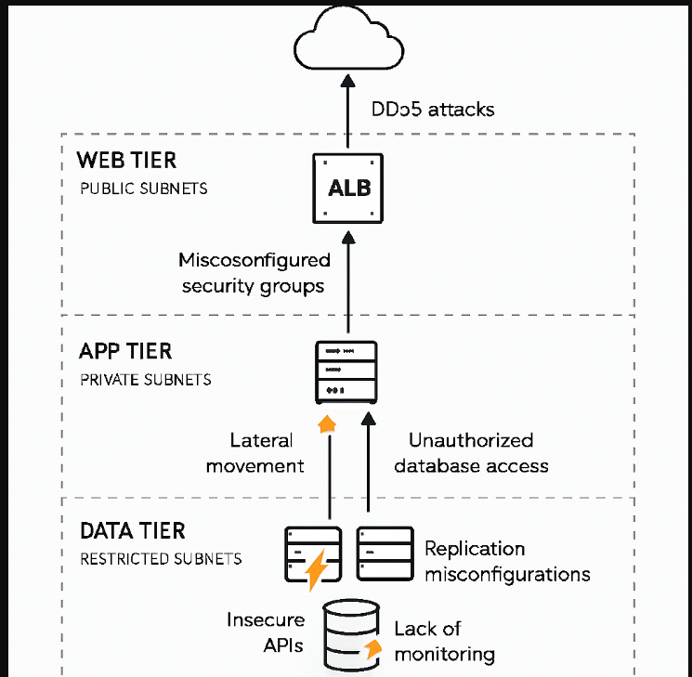
Security Threats in VPC Design
1. Misconfigured Route Tables
- Threat: Incorrect routing can accidentally expose private subnets to the internet, bypassing intended isolation.
- Impact: Data tier resources (databases) could be reachable from outside.
📖 Source: AWS Docs – VPC Security Best Practices
https://docs.aws.amazon.com/vpc/latest/userguide/vpc-security-best-practices.html (docs.aws.amazon.com in Bing) (bing.com in Bing)
Overly Permissive Security Groups
- Threat: Security groups act as stateful firewalls, but if configured with wide open rules (e.g., 0.0.0.0/0 inbound), attackers can exploit exposed services.
- Impact: Web tier ALBs or bastion hosts could be compromised, leading to entry into private tiers.
📖 Source: AWS Docs – Security Groups
https://docs.aws.amazon.com/vpc/latest/userguide/VPC_SecurityGroups.html (docs.aws.amazon.com in Bing) (bing.com in Bing)
3. Weak Network ACL Configurations
- Threat: NACLs are stateless and must explicitly allow/deny traffic. Misconfigured ACLs can either block legitimate traffic or allow malicious flows.
- Impact: Attackers could bypass subnet boundaries or exploit open ports.
📖 Source: AWS Docs – Network ACLs
https://docs.aws.amazon.com/vpc/latest/userguide/vpc-network-acls.html (docs.aws.amazon.com in Bing) (bing.com in Bing)
4. NAT Gateway Misuse
- Threat: NAT Gateways allow outbound traffic from private subnets. If not restricted, compromised app servers could exfiltrate sensitive data.
- Impact: Data leakage through unrestricted outbound connections.
📖 Source: Hyperglance – AWS VPC Security Best Practices
https://www.hyperglance.com/blog/aws-vpc-security-best-practices/ (hyperglance.com in Bing) (bing.com in Bing)
5. Lateral Movement Between Tiers
- Threat: If micro-segmentation is not enforced, attackers who compromise the web tier can move laterally into the app or data tiers.
- Impact: Escalation from public-facing servers to sensitive databases.
📖 Source: DEV Community – Pentesting AWS VPCs
https://dev.to/kachi/building-a-scalable-secure-multi-tier-architecture-on-aws-my-recent-infrastructure-project-3g5a (dev.to in Bing) (bing.com in Bing)
6. Insufficient Monitoring
- Threat: Without VPC Flow Logs and CloudTrail, malicious activity (port scans, unauthorized API calls) may go undetected.
- Impact: Delayed detection of breaches and compliance violations.
📖 Source: AWS Docs – VPC Flow Logs
https://docs.aws.amazon.com/vpc/latest/userguide/flow-logs.html (docs.aws.amazon.com in Bing) (bing.com in Bing)

7. Accidental Public Exposure via Route Table Leaks:
The architecture relies on Logical Separation using IP CIDR blocks and Route Tables rather than physical isolation. Mismanagement of these route tables could lead to "leaks" that accidentally expose private subnets (App or Data tiers) directly to the Internet Gateway.
8. Targeting the NAT Gateway for Data Exfiltration:
The design uses a NAT Gateway in the Public Subnet to allow private App Tier instances to reach the internet for patches. If an App Tier instance is compromised, an attacker can use this existing egress path to exfiltrate sensitive data to an external server
9. Lateral Movement via Compromised Web Tier:
The Web Tier has inbound connectivity from the internet via the Internet Gateway. If an attacker compromises a resource in the Web Tier (such as an ALB or Bastion host), they could attempt to move laterally into the App Tier, as the App Tier is designed to accept inbound traffic from the Web Tier.
10. Single Layer of Stateful Defence:
While the architecture uses a "dual-layer defense" with NACLs and Security Groups, Security Groups act as the primary stateful firewall for every network interface. A single misconfiguration in a Security Group could bypass the micro-segmentation intended to isolate servers within the same subnet.
11. Compromise of Management Access Points:
The Web Tier hosts Bastion Hosts or VPN endpoints for administrative access. These represent high-value targets; if compromised, they provide a direct "jumping point" into the private App and Data tiers, bypassing standard external traffic filters.
12. Dependency on Managed Service Availability:
The architecture relies heavily on managed components like the NAT Gateway for operational resilience. While harder to compromise than a manual NAT instance, a service-level failure or a massive DDoS targeting the NAT Gateway's Elastic IP could sever the App Tier's ability to receive critical security patches.

Criticality and Cost Optimization
There are always cost benefit considerations while designing a system. Same is the case of Security measures – the criticality and cost impact. From this point of following may be useful while addressing the mitigation measures:

Criticality and Costs
🔥 Threat Severity vs 💰 Cost Optimization Priority
Threat Scenario | Severity | Cost Optimization Priority | Why It Matters
Misconfigured Security Groups | 🔴 High | ✅ High | Easy to fix with tight rules; no extra cost.
DDoS Attacks on Web Tier | 🔴 High | ⚠️ Medium | AWS Shield Standard is free; Advanced is costly.
Lateral Movement to App Tier | 🔴 High | ✅ High | Microsegmentation via SGs is low-cost and effective.
Insecure APIs | 🟠 Medium | ⚠️ Medium | API Gateway adds cost; IAM and throttling help.
NAT Gateway Misuse | 🟠 Medium | 🔼 High | NAT Gateway egress is expensive; monitor usage.
Unauthorized Database Access | 🔴 High | ✅ High | IAM and encryption are built-in; no extra spend.
Replication Misconfigurations | 🟡 Low | ⚠️ Low | Rare but impactful; periodic review suffices.
Lack of Monitoring | 🔴 High | 🔼 Medium | Enable logs selectively to reduce spend.

Optimization Strategy
• Focus first on high-severity, low-cost fixes: tighten security groups, enforce IAM, isolate tiers.
• Monitor NAT Gateway usage: consider NAT instances for low-volume traffic.
• Use built-in AWS tools: CloudTrail, IAM roles, encryption — all offer strong security without extra cost.
• Enable logging selectively: VPC Flow Logs only on critical subnets to reduce data ingestion costs.

Security threats arising from delivery models
Apart from the design of the VPC and setting up Security Groups or NACLs, one key consideration from security point of view is to be considered as what is the delivery model.
The delivery model of a cloud network—whether IaaS, PaaS, or SaaS—fundamentally redefines the "Shared Responsibility Model." This model dictates the division of security tasks between the cloud service provider (CSP) and the customer. As you move from IaaS toward SaaS, the provider manages more of the stack, but the customer's responsibility for data and identity remains constant.
Security Impact by Delivery Model
Delivery Model | Network Security Impact | Customer Responsibility | Provider Responsibility
IaaS (Infrastructure) | Maximum Control & Complexity. The customer builds the entire virtual network (VPCs, Subnets). | Firewall rules (SGs/NACLs), OS patching, VPNs, and internal routing. | Physical security, virtualization layer, and hardware.
PaaS (Platform) | Identity-Centric Security. The network perimeter is often managed by the provider; security relies on API permissions. | IAM policies, API security, and database access configurations. | Network isolation, OS hardening, and runtime environments.
SaaS (Software) | Data & Access Focus. The network is a "black box." Security is enforced at the user and data level. | MFA, user permissions, and data classification. | Entire network stack, application code, and infrastructure.

Detailed Security Analysis
1. IaaS: Software-Defined Perimeter Control
In an IaaS model (e.g., AWS VPC, Azure VNet), the customer is the "Network Architect." The primary security impact is the requirement for manual configuration of stateful and stateless firewalls.
- Risk: The most significant threat is misconfiguration. A single open port (e.g., RDP or SSH) or an overly broad Security Group rule can expose the entire internal network.
- Source: Check Point: Shared Responsibility in IaaS
2. PaaS: Abstracted Networking
In PaaS (e.g., Google App Engine, Azure SQL), the provider handles the underlying network infrastructure. The security impact is a shift from "IP-based" security to "Identity-based" security.
- Benefit: The provider automatically patches the OS and manages network-level DDoS protection.
- Risk: "Identity is the new perimeter." If an attacker steals an API key or an IAM token, they can often access the service regardless of the network location unless VPC Service Controls are implemented.
- Source: Microsoft: Security in Platform as a Service
3. SaaS: Perimeter-less Security
In SaaS (e.g., Microsoft 365, Salesforce), the customer has zero control over network routing or firewalling. Security is managed through Zero Trust principles.
- Impact: Since the network is managed by the provider, the customer must focus on Conditional Access (e.g., only allowing logins from specific IP ranges or compliant devices).
- Risk: Data exfiltration via compromised accounts is the primary threat, as the application is globally accessible over the public internet.
- Source: CrowdStrike: SaaS Security Challenges

Real Life examples of Security incidences for a Single VPC.
Real-world incidents in single-cloud, three-tier VPC architectures often involve misconfigurations, insecure APIs, lateral movement, and database exposure. These cases show how weaknesses in one tier can cascade across the entire environment.

⚠️ Real-Life Case Examples (3-Tier Cloud VPC)
Tier | Incident Example | Brief Explanation | Source
Web Tier (Public Subnets) | Capital One AWS Breach (2019) | A misconfigured Web Application Firewall (WAF) allowed an attacker to exploit SSRF (Server-Side Request Forgery) and access sensitive data from the public-facing tier. | Capital One Breach – CSO Online (csoonline.com in Bing) (bing.com in Bing)
App Tier (Private Subnets) | Tesla Kubernetes Console Exposure (2018) | Tesla left a Kubernetes admin console unsecured in a private subnet, enabling attackers to run cryptojacking workloads and pivot deeper into the app tier. | Tesla Cloud Hack – RedLock Report (redlock.io in Bing) (bing.com in Bing)
Data Tier (Restricted Subnets) | MongoDB Cloud Exposures (2017) | Thousands of misconfigured MongoDB instances in cloud VPCs were left open without authentication, leading to mass data theft and ransom demands. | MongoDB Ransom Attacks – Wired (wired.com in Bing) (bing.com in Bing)
Cross-Tier Movement | Verizon AWS S3 Leak (2017) | A contractor misconfigured S3 bucket permissions, allowing attackers to move laterally from app tier logs into sensitive customer data. | Verizon S3 Data Leak – ZDNet (zdnet.com in Bing) (bing.com in Bing)

Improvement Suggestions

Executive Summary

Reference list

